河南融德启道国际贸易有限公司

公司简介
河南融德启道国际贸易有限公司位于中国河南省郑州市。作为一家具有一定实力的种植、仓储、贸易联合公司，我们参与大蒜种植、分选到成品储存的全过程。我司从事国内大蒜业务已有近20年历史，现在我们有独立的进出口权，大蒜出口贸易规模亦在日益扩大，以良好的信誉和贴心的服务得到了客户的信赖！
我们致力于提供绿色、安全、可靠的大蒜和食品，并致力于为客户创造更大的价值！

Company profile

Henan Rongde Qidao International Trade Co., Ltd., is Located in Zhengzhou, Henan province, China. As an planting,warehousing and trading combo company with definite strength, we engaged in entire process from planting garlic, sorting to finished product storage.
Our company has been engaged in domestic garlic business with abund professional experiences for nearly 20 years , now we have independent import and export rights, and the scale of export trade is also expanding day by day. With good reputation and considerate service, we have won the trust of customers.
We are committed to providing green, safe, reliable garlic and other foods, and are committed to creating greater value for customers!

主要产品介绍（Introduction of main products）

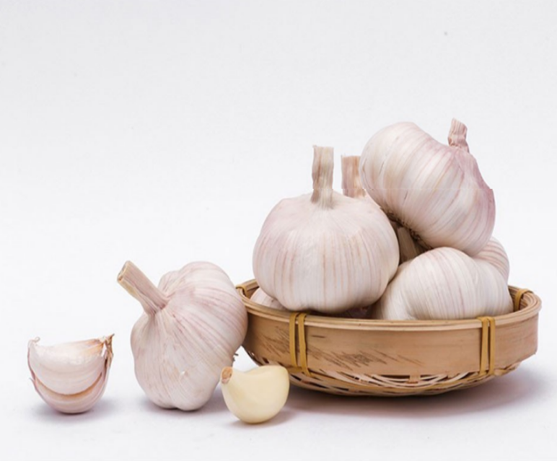
大蒜（Garlic）
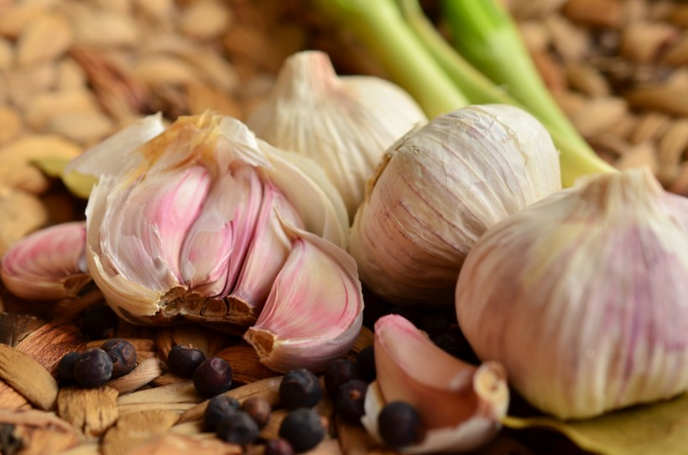

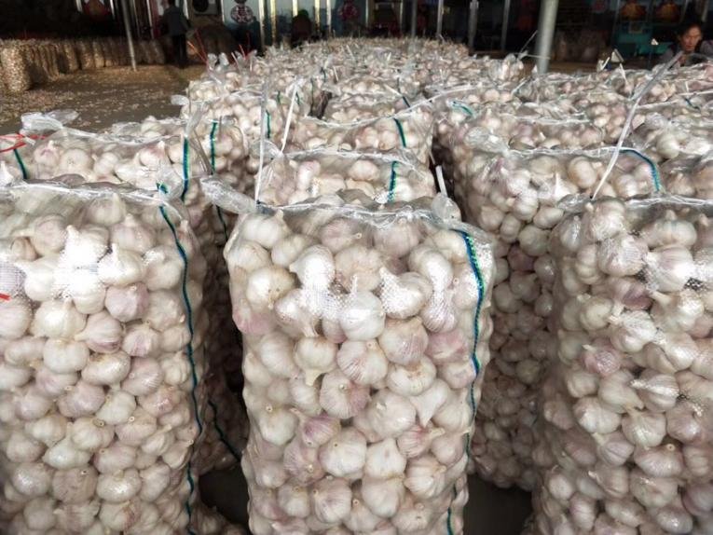
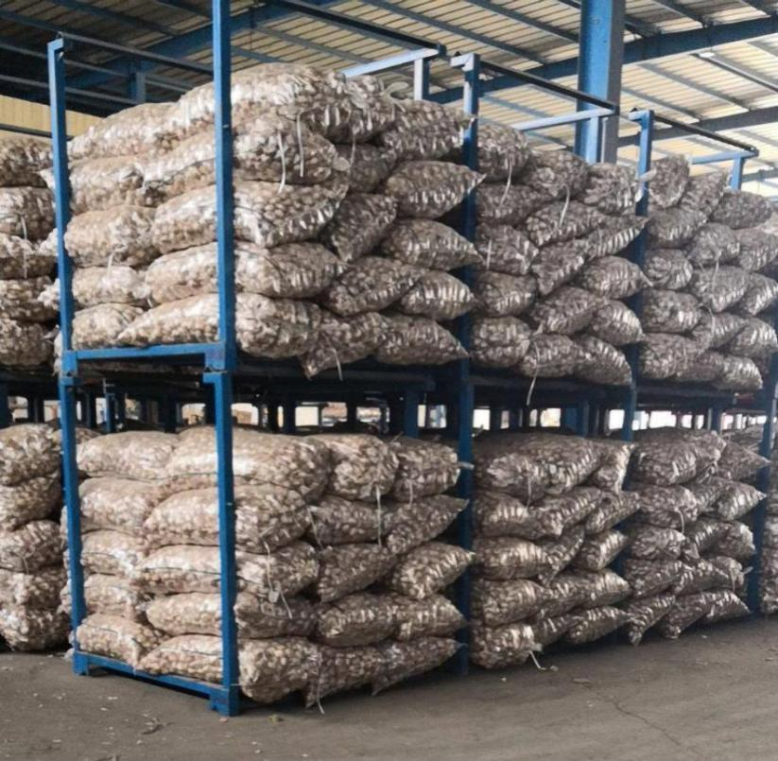

- 产品优势(Product advantage)

我们的大蒜主要来源于中国大蒜之乡-河南中牟，大蒜在当地已有2000多年的栽培历史。“中牟大白蒜”是中国地理标志产品，品质和味道上乘。
Our garlic mainly comes from Zhongmou County, Henan Province, the hometown of garlic in China. Locally, Garlic has been cultivated for more than 2000 years. "Zhongmou big white garlic" is a geographical indication product in China, with excellent quality and taste.
- 传统种植(The traditional planting)
2、自然生长(Natural growth)
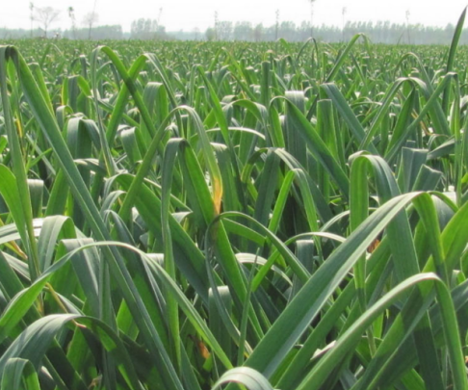

- 人工修剪( Artificial pruning)
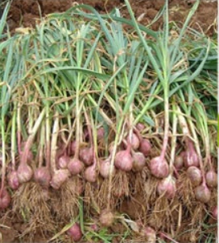
- 精心挑选(Carefully selected)
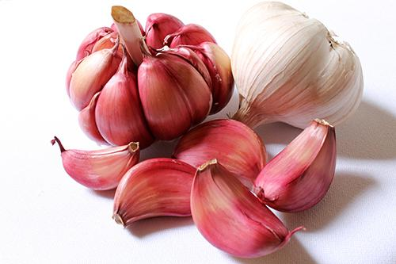
5、自动化筛选（Automatic screening）
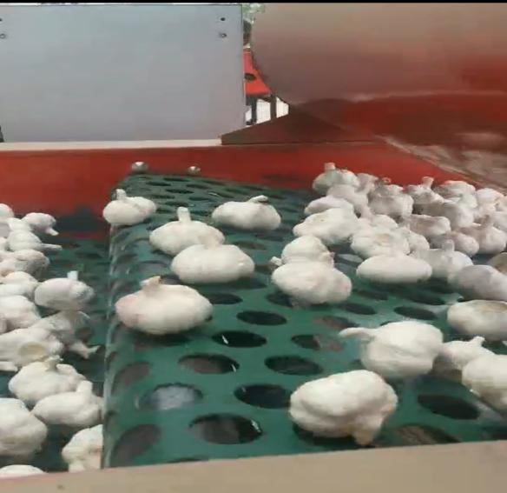
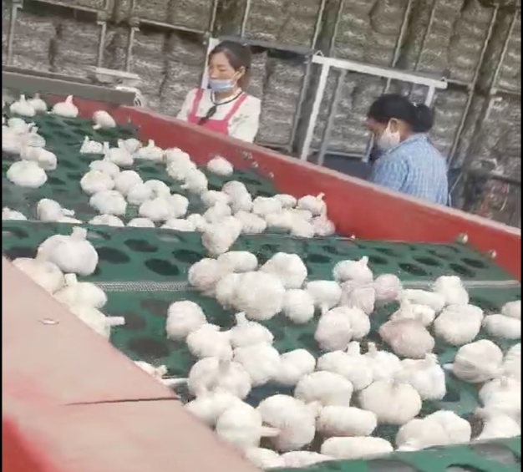

Description of white garlic 白大蒜介绍
Product（产品） | Normal white garlic / red garlic / purple garlic/Chinese Garlic/  Pure white garlic
Size（尺寸） | 4.5-5.0cm,5.0-5.5cm,5.5-6.0cm,6.0-6.5cm  4.5cm; 5.0cm; 5.5cm; 6.0cm; 6.5cm
Load Ability （装运） | 12mts for 20'rfL, 25-28mts/40'rhr  12吨/ 20'rf，25-28吨/40尺冻柜
Transporting and storing temperature  （运输和储存温度） | -3 - 0°C
Loose Packing  （散装） | 5kg/8kg/9kg/10kg/20kg mesh bag 网袋
 | 8kg/9kg/10kg carton 纸箱
Inner Small Packing  内包装 | 1kg bagx10/10kg ; 3pcs/bag, 10kgs
 | 500g bagx20/10kg ; 4pcs/bag
 | 250g bagx40/10kg ; 5pcs/bag,
 | 200g bagx50/10kg
Customized packing  包装定制 | according to clients' requirements 按照客户需求包装
Payment terms  付款条款 | T/T or L/C at sight 电汇或即期信用证
Delivery time发货时间 | Within 7-15 days after receiving the deposit or acceptable L/C  预付款或者可接受的信用证收到后7-15天内

- Size 6.0cm garlic
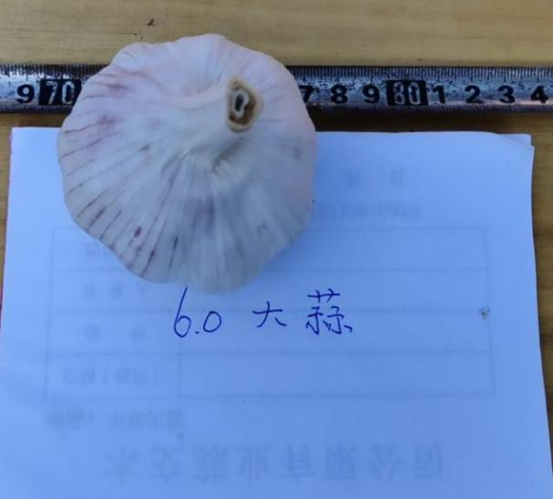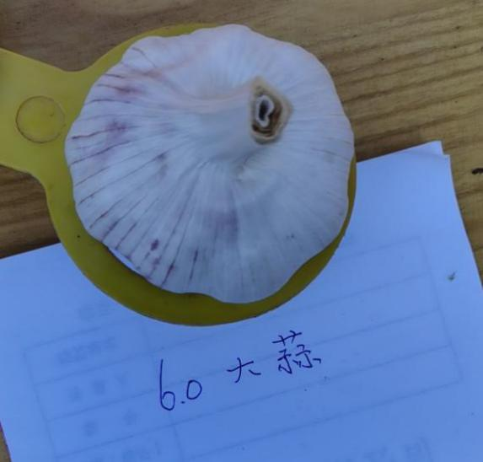
- Size 5.5cm garlic
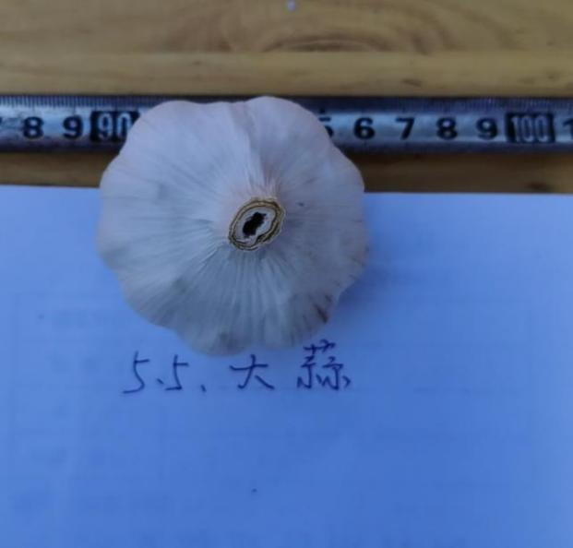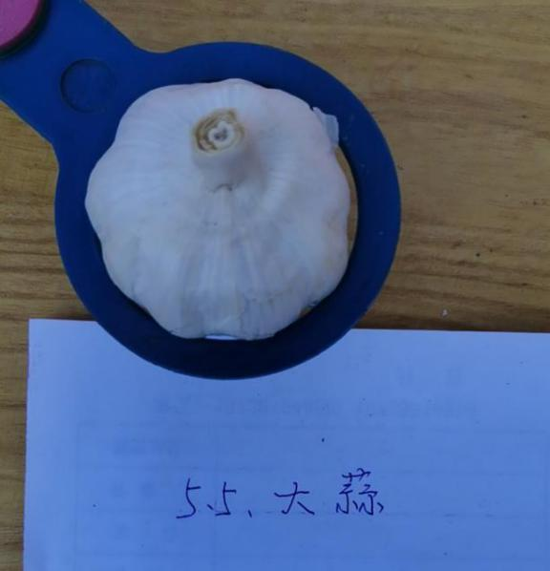
- Size 5.0cm garlic
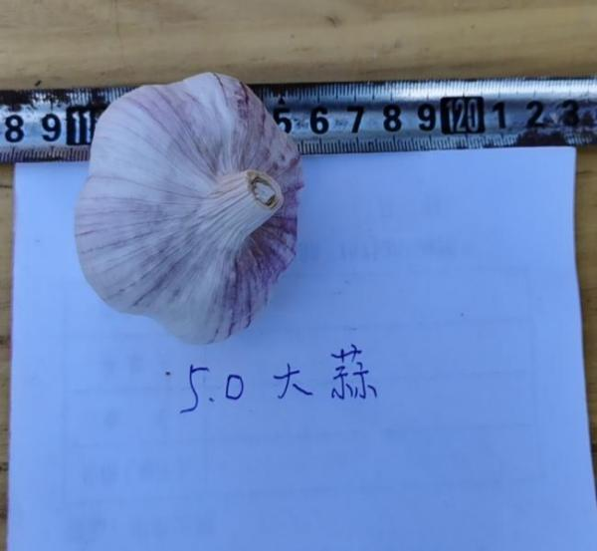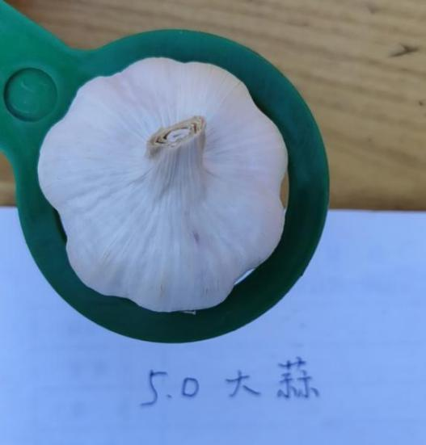

- Package: mesh bag
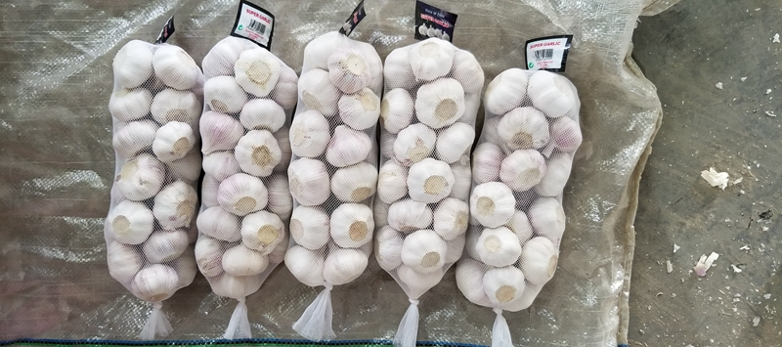

- Carton package

